Contents
Core Java Section 3
1. What is features of Java 3
2. Diff between JDK, JRE, and JVM? 3
3. JVM architecture, generations and memory areas 4
4. What is a classloader? 4
5. Explain oops concept in java details 4
6. Difference between Heap and Stack memory? 4
7. what is covariant 5
8. What is variable argument(vargs) 6
9. can static method override and why not? 6
10. What is Garbage Collection in java? 7
11. Type of access specifier in java? (special focus on protected) 7
12. When to use of static and default method of functional interface use case? 8
13. Diff between Shallow Copy vs Deep Copy 8
14. In details explanation of equals () and hashcode() method 9
15. Difference between ‘==’ operator and Equals method in java? 9
16. What is hashcode() method in java? 9
17. What is string literal vs string object 10
18. What is String pool? 10
19. What Is an Immutable Object? 11
20. Why the string in java immutable? 11
21. Diff between the transient and volatile keyword and when to use it. 12
22. What is autoboxing and unboxing in java 12
23. Typecasting in Java 13
24. Why variables in interface are public, static and final? 13
25. What is feature of Java 8 13
26. What is feature of Java 11? 13
27. What is feature of Java 17? 14
28. What is feature of Java 21? 14
29. What is lambda expression in java? 14
30. What is method reference in java? 14
31. can static method override and why not? 15
32. How to make the object/use defined class immutable in java? 15
33. What is diamond pattern in java ? 15
34. What is 100% abstraction in java how to achieve it? 15
35. Diff between the callable and runnable in java? 15
36. Different rules of method overriding? 16
37. Composition vs. Inheritance: A Detailed Comparison? 16
38. Explain String Buffer,String and String Builder in details 16
39. Explain the serialization in java in detail 16
40. Explain the cohesion in java? 16
41. Deep copy vs Shallow in depth and when to use 16
42. What are Records in Java, and why are they used? 16
Exception Handling 18
1. Explain the exception hierarchy? 18
2. Explain the rule of handling the exception? 18
3. Diff between throw and throws keyword? 18
4. Tell me the output of below program? 19
Code Section 20
1. Reverse the string? 20
2. Calculate the occurrence of each character using the stream api from the string? 20

Core Java Section

What is features of Java
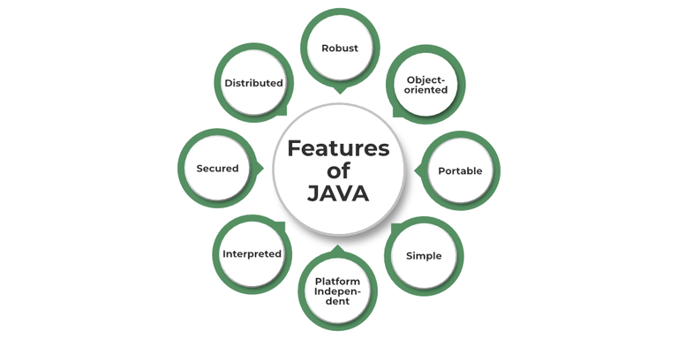

- Simple: Java is quite simple to understand and the syntax
- Platform Independent: Java is platform independent means we can run the same program in any software and hardware and will get the same result.
- Interpreted: Java is interpreted as well as a compiler-based language.
- Robust: features like Garbage collection, exception handling, etc that make the language robust.
- Object-Oriented: Java is an object-oriented language that supports the concepts of class, objects, four pillars of OOPS, etc.
- Secured: As we can directly share an application with the user without sharing the actual program makes Java a secure language.
- High Performance: faster than other traditional interpreted programming languages.
- Dynamic: supports dynamic loading of classes and interfaces.
- Distributed: feature of Java makes us able to access files by calling the methods from any machine connected.
- Multithreaded: deal with multiple tasks at once by defining multiple threads
- Architecture Neutral: it is not dependent on the architecture.

Diff between JDK, JRE, and JVM?
JDK | JRE | JVM
JDK provides env to develop and execute the java application | JRE provides env to run only the java application | In the JRE, JVM is responsible to run the java program line by line
JDK = JRE + Development tools | JRE = JVM + Library classes

Resources: https://youtu.be/eaAqwTdUAAo?si=KScUVJiNygsqtHpQ

JVM architecture, generations and memory areas
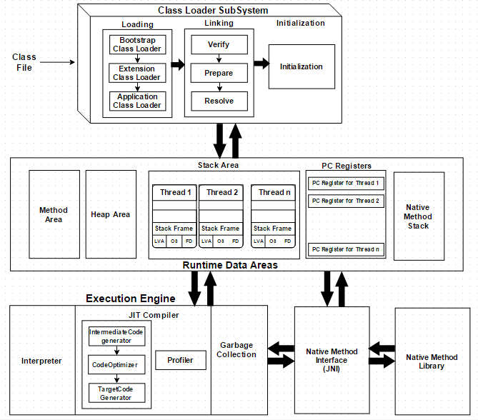
Resource: https://www.turing.com/kb/java-virtual-machine#bootstrap-classloader

What is a classloader?
Classloader is the part of JRE(Java Runtime Environment), during the execution of the bytecode or created .class file classloader is responsible for dynamically loading the java classes and interfaces to JVM(Java Virtual Machine). Because of classloaders Java run time system does not need to know about files and file systems.

Explain oops concept in java details
Resources: https://stackify.com/oops-concepts-in-java/

Difference between Heap and Stack memory?
Parameter | Stack Memory | Heap Space
Application | Stack is used in parts, one at a time during execution of a thread | The entire application uses Heap space during runtime
Size | Stack has size limits depending upon OS, and is usually smaller than Heap | There is no size limit on Heap
Storage | Stores only primitive variables and references to objects that are created in Heap Space | All the newly created objects are stored here,object & array as well
Order | It’s accessed using Last-in First-out (LIFO) memory allocation system | This memory is accessed via complex memory management techniques that include Young Generation, Old or Tenured Generation, and Permanent Generation.
Life | Stack memory only exists as long as the current method is running | Heap space exists as long as the application runs
Efficiency | Much faster to allocate when compared to heap | Slower to allocate when compared to stack
Allocation/Deallocation | This Memory is automatically allocated and deallocated when a method is called and returned, respectively | Heap space is allocated when new objects are created and deallocated by Gargabe Collector when they’re no longer referenced

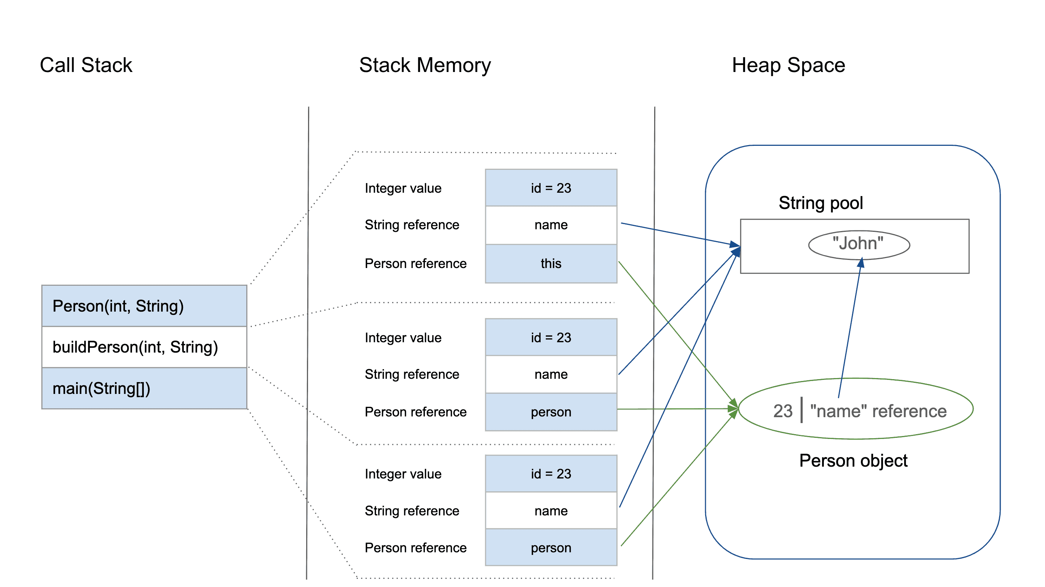

Resources : https://www.baeldung.com/java-stack-heap

what is covariant
"In earlier versions of Java, you couldn't change the return type of an overridden method. However, with the introduction of covariant return types in Java, you can override a method in a subclass and change the return type, provided that the new return type is a subclass of the return type declared in the parent class."

class Animal {
public Animal getAnimal() {
return new Animal();
}
}
class Dog extends Animal {
@Override
public Dog getAnimal() { // Covariant return type
return new Dog();
}
}

What is variable argument(vargs)
Varargs is a feature in Java that allows methods to accept a variable number of arguments. Varargs are defined by using three dots in a method's parameter, such as public int add(int ... i). Varargs can only be used as the final argument in a method. Varargs can improve code readability and reduce the need for multiple overloaded methods
Eg.
private static String get(int val, String... args) {
String str = "";
for (String s : args) {
str = str + s;
}
return String.valueOf(val) + str;
}

can static method override and why not?
No, static methods cannot be overridden in Java because they belong to a class, not an instance, and cannot be dynamically changed. However, static methods can be hidden in a subclass using the same method name, but this is not considered true overriding.
E.g
class Parent {
public static void display() {
System.out.println("This is the static method in the Parent class.");
}
}
class Child extends Parent {
public static void display() {
System.out.println("This is the static method in the Child class.");
}
}
public class HelloWorld {
public static void main(String[] args) {
Parent.display();
Child.display(); // Output: This is the static method in the Child class.
Parent obj = new Child();
obj.display(); // Output: This is the static method in the Parent class.
}
}

What is Garbage Collection in java?
In Java, garbage collection is the process of automatically managing memory by reclaiming memory occupied by objects that are no longer in use. This relieves developers from the burden of manual memory management, which can be error-prone and time-consuming.
Benefits of Garbage Collection in Java:
- Improved Developer Productivity: Developers can focus on application logic instead of memory management.
- Reduced Memory Leaks: Garbage collection helps prevent memory leaks, which occur when objects are no longer needed but are not deallocated.
- Enhanced Security: The garbage collector helps prevent security vulnerabilities that can arise from manual memory management errors.
Types of Garbage collection?
- Minor garbage collection: Also known as young generation garbage collection, this type of garbage collection is used to collect and reclaim memory that is used by short-lived objects (objects that are quickly created and discarded).
- Major garbage collection: Also known as old-generation garbage collection, this type of garbage collection is used to collect and reclaim memory that is used by long-lived objects (objects that survive multiple minor garbage collections and are promoted to the old generation).
- Full garbage collection: During full garbage collection, memories from all generations are collected and reclaimed, including memories of young and old. A full garbage collection normally takes longer to complete than a minor or major garbage collection which causes that app to pause temporarily.

Type of access specifier in java? (special focus on protected)
in Java, Access modifiers help to restrict the scope of a class, constructor, variable, method, or data member. It provides security, accessibility, etc to the user depending upon the access modifier used with the element. Let us learn about Java Access Modifiers, their types, and the uses of access modifiers in this article.
Types of Access Modifiers in Java
There are four types of access modifiers available in Java:
- Default – No keyword required
- Private
- Protected
- Public

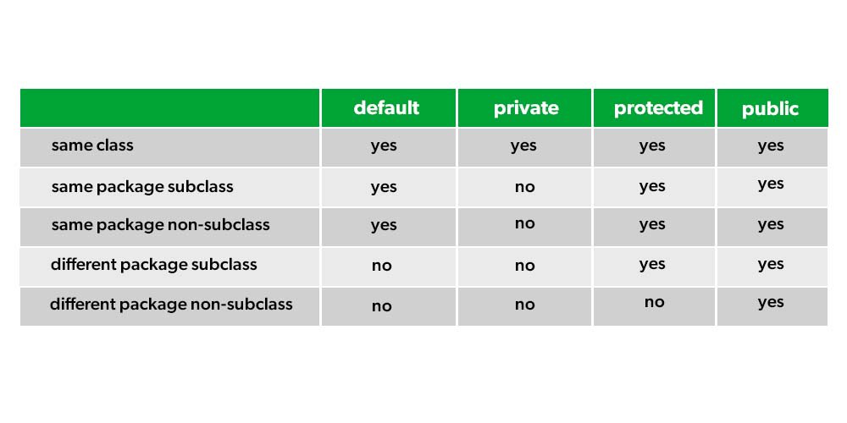

Resources: https://www.geeksforgeeks.org/access-modifiers-java/

When to use of static and default method of functional interface use case?
Default method
  - When you want to provide a default behaviour for a method, but still allow the implementing classes to override it if needed.
  - When extending an interface and you don't want to force all implementers to provide their own implementation of a new method.
Static method
  - When you need a utility or helper method that operates independently of any instance of the interface.
  - When you want to ensure the method cannot be overridden or changed by implementing classes.
  - If they will try to override it, then it will act like method hiding

Diff between Shallow Copy vs Deep Copy
Shallow Copy | Deep Copy
Shallow Copy stores the references of objects to the original memory address. | Deep copy stores copies of the object’s value.
Shallow Copy reflects changes made to the new/copied object in the original object. | Deep copy doesn’t reflect changes made to the new/copied object in the original object.
Shallow Copy stores the copy of the original object and points the references to the objects. | Deep copy stores the copy of the original object and recursively copies the objects as well.
A shallow copy is faster. | Deep copy is comparatively slower.

In details explanation of equals () and hashcode() method
Resources: https://www.digitalocean.com/community/tutorials/java-equals-hashcode

Difference between ‘==’ operator and Equals method in java?
== Operator:
- Reference Comparison:
The == operator compares the memory addresses of two objects. It checks whether the two references point to the same object in memory.
- Primitive Types:
For primitive types (e.g., int, char, boolean), the == operator compares their values directly.
equals() Method:
- Content Comparison: The equals() method compares the actual content of two objects.
- Object Types: For object types, the default implementation of equals() (inherited from the Object class) also performs a reference comparison. However, you can override the equals() method in your custom classes to define a custom content comparison logic.
E.g
String s1 = "Hello";
String s2 = "Hello";
String s3 = new String("Hello");
System.out.println(s1 == s2); // Output: true (same memory location)
System.out.println(s1 == s3); // Output: false (different memory locations)
System.out.println(s1.equals(s3)); // Output: true (same content)

What is hashcode() method in java?
In Java, the hashCode() method is used to generate a unique integer value for an object. This value is known as the hash code and is used by data structures like HashMap and HashSet to efficiently store and retrieve objects.
Key Points:
- Purpose:
The primary purpose of hashCode() is to facilitate efficient data retrieval in hash-based collections.
- Inheritance:
The hashCode() method is defined in the Object class, which is the root of the Java class hierarchy. Therefore, all Java objects inherit this method.
- Contract:
The hashCode() method must adhere to a specific contract:
  - If two objects are equal according to the equals () method, they must have the same hash code.
  - If the hashCode() method is called multiple times on the same object, it must consistently return the same integer value, provided the object's state hasn't changed.
  - It is not required that two unequal objects have different hash codes, but it is recommended for better performance.

What is string literal vs string object
String literal
String str = “GeeksForGeeks”;
This is string literal. When you declare string like this, you are actually calling intern() method on String. This method references internal pool of string objects. If there already exists a string value “GeeksForGeeks”, then str will reference of that string and no new String object will be created.

String Object
String str = new String(“GeeksForGeeks”);
This is string object. In this method JVM is forced to create a new string reference, even if “GeeksForGeeks” is in the reference pool.
Therefore, if we compare performance of string literal and string object, string object will always take more time to execute than string literal because it will construct a new string every time it is executed.

What is String pool?
A Java String Pool is a place in heap memory where all the strings defined in the program are stored. A separate place in a stack is there where the variable storing the string is stored. Whenever we create a new string object, JVM checks for the presence of the object in the String pool, If String is available in the pool, the same object reference is shared with the variable, else a new object is created.
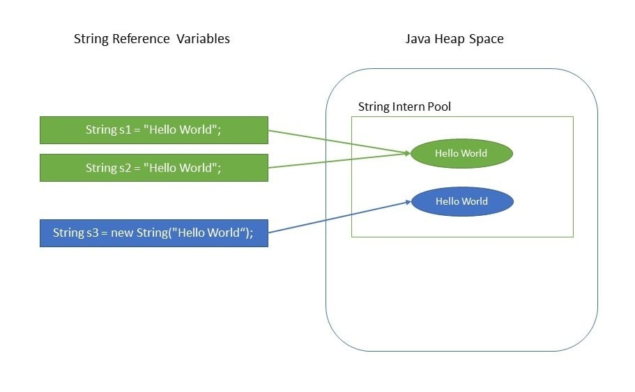

What Is an Immutable Object?
An immutable object is an object whose internal state remains constant after it has been entirely created. This means that once the object has been assigned to a variable, we can neither update the reference nor mutate the internal state by any means.

Why the string in java immutable?
In Java, strings are immutable, meaning once a String object is created, its content cannot be changed. This design choice is deliberate and has several advantages:
1. Security
- Strings are widely used in many areas such as usernames, passwords, and network connections. Since strings are immutable, their values cannot be altered once created, providing a layer of security against malicious modifications during runtime.
2. Thread Safety
- Immutable objects are inherently thread-safe because their state cannot be modified after they are created. Since multiple threads can access a string simultaneously without the risk of any one thread changing it, it avoids synchronization issues and simplifies code in concurrent applications.
3. String Pooling (Performance Optimization)
- Java uses a string pool for memory efficiency. When you create a string, Java checks the pool for an existing string with the same value. If found, it returns a reference to the existing string instead of creating a new one. If strings were mutable, modifying one string could affect other parts of the program unintentionally, breaking the concept of the pool.
4. Hashcode Caching
- The immutability of strings allows Java to cache their hash codes. Since the content of the string doesn't change, the hash code only needs to be calculated once. This makes strings efficient for use in hash-based collections like HashMap or HashSet.
5. Memory Efficiency
- Since strings are immutable, memory can be shared safely among different string variables. When substrings are created, they share the same underlying character array, reducing memory overhead.

Diff between the transient and volatile keyword and when to use it.
Transient | Volatile
The Transient marked variable prevents it from being serialized. | The Volatile marked variable follows happen-before relationship on visibility in multithreaded java program which reduces the risk of memory consistency errors.
It gives control and flexibility over to exclude some object methods from serialization process. | It prevents JVM from doing re-ordering which could compromise synchronization.
During deserialization they are initialized with a default value. | They are not initialized with a default value.
It cannot be used with the static keyword as static variable do not belong to individual instance. During serialization, only object’s current state is concerned. | It can be used with the static keyword.
It cannot be used with the final keyword. Although JVM doesn’t complain about it but during deserialization one will face problem of reinitializing a variable. | It can be used with the final keyword

What is autoboxing and unboxing in java
In Java, autoboxing and unboxing are automatic conversions between primitive types (like int, double, boolean) and their corresponding wrapper classes (like Integer, Double, Boolean).
Autoboxing:
- It is the automatic conversion of a primitive type to its corresponding wrapper class object.
- For example, converting an int to an Integer.
- This happens when you pass a primitive value to a method that expects an object of the corresponding wrapper class.
Unboxing:
- It is the automatic conversion of a wrapper class object to its corresponding primitive type.
- For example, converting an Integer to an int.
- This happens when you use a wrapper class object in a context where a primitive type is expected.
Benefits:
- Autoboxing and unboxing make the code more concise and readable by eliminating the need for explicit conversions.
- They allow you to use primitive types seamlessly with collections (which can only store objects).
Considerations:
- While convenient, excessive autoboxing and unboxing can impact performance, particularly in performance-critical code sections.
- Be mindful of the potential for NullPointerException when unboxing a null wrapper object.

Typecasting in Java
Typecasting in Java is the process of converting one data type to another data type using the casting operator. When you assign a value from one primitive data type to another type, this is known as type casting. To enable the use of a variable in a specific manner, this method requires explicitly instructing the Java compiler to treat a variable of one data type as a variable of another data type.
Resources: https://www.geeksforgeeks.org/typecasting-in-java/

Why variables in interface are public, static and final?
Static: We don’t create the instance of interface, so for accessing this variable we have only interface name for that purpose.
Final: To make them constant. If 2 classes implement the same interface and you give both the right to change the value, conflict will occur in the current value of the variable, which is why only one time initialization is permitted.

What is feature of Java 8
- Functional Interfaces and Lambda Expressions
- forEach() Method In Iterable Interface
- Optional Class
- Default And Static Methods In Interfaces
- CompletableFuture
- Java Stream API For Bulk Data Operations On Collections
- Java Date Time API
- Collection API Improvements
- Java IO Improvements
- Miscellaneous Core API Improvements
- Base64 Encode Decode
Resources: https://www.interviewbit.com/blog/java-8-features/

What is feature of Java 11?
- Local-Variable Syntax for Lambda Parameters
- Single-File Source Code Programs (we can run java file in single command: java Main.java)
- New String Methods
- Nest-Based Access Control
- ZGC (Experimental)
- HTTP Client
Resources: https://medium.com/@himani.prasad016/java-11-features-164c2094e868 , https://www.baeldung.com/java-11-new-features

What is feature of Java 17?
- Text Blocks(Json supports in triple quotes)
- ‘record’ Type
- Improved Switch Statements
- Helpful NullPointerException
- ‘sealed’ Classes
- The Parallel Garbage Collector(Available in Java 17) is 16.39% faster than the G1 Garbage Collector(Used in Java 11).
Resources: https://medium.com/@brijesh.sriv.misc/complete-list-of-features-in-java-17-lts-5f4f1fa5fe67

What is feature of Java 21?
Resources: https://www.baeldung.com/java-lts-21-new-features#:~:text=Java%2021%20introduced%20three%20new,them%20have%20successors%20and%20predecessors.

What is lambda expression in java?
A lambda expression is an anonymous method that is used to implement the abstract method of the functional interface. It has three parts — First is the parameter list then the arrow (->) which is the new operator introduced in Java 8 and then we have the abstract method’s body.
E.g: There are some predefined functional interace in java.util.function package
Consumer, Supplier, Predicate, Function, BiConsumer, BiFunction, UnaryOperator, Runnable, Clonable

What is method reference in java?
In Java, a method reference is a shorthand notation for a lambda expression that calls a single method. It provides a way to refer to a method without explicitly invoking it.
Benefits of using method references:
- Concise code:
They make your code more readable and compact, especially when dealing with lambda expressions that only call a single method.
- Improved readability:
Method references can often make the purpose of your code clearer, as they directly point to the method being used.
Types of method references:
- Reference to a static method: ClassName::staticMethodName
- Reference to an instance method of a particular object: objectReference::instanceMethodName
- Reference to an instance method of an arbitrary object of a particular type: ClassName::instanceMethodName
- Reference to a constructor: ClassName::new

can static method override and why not?
It is not possible to override the static method in java but if try to do so the method hinding will come In picture as method override is the concept related to runtime polymorphism which only possible with the help of instance but this is the static method which deals with the class, so that is why static method override is not possible in java, will convert it into method hinding if you force to do so.

How to make the object/use defined class immutable in java?
- The class must be declared as final so that child classes can’t be created.
- Data members in the class must be declared private so that direct access is not allowed.
- Data members in the class must be declared as final so that we can’t change the value of it after object creation.
- A parameterized constructor should initialize all the fields performing a deep copy so that data members can’t be modified with an object reference.
- Deep Copy of objects should be performed in the getter methods to return a copy rather than returning the actual object reference)

Resources: https://www.geeksforgeeks.org/create-immutable-class-java/

What is diamond pattern in java ?
Diamond Problem is a problem faced during Multiple Inheritance in Java, whenever we try to call the method from parent class but both the parent class have same method, then this issue encounters.
Resources: https://www.geeksforgeeks.org/diamond-problem-in-java/

What is 100% abstraction in java how to achieve it?
Yes, 100% abstraction is possible in Java using interfaces.
Here's why:
- Interfaces:
Interfaces in Java can only contain method signatures (no method bodies) and constant variables. This means that they define what a class should do, but not how it should do it. This is the essence of abstraction.
- Abstract Classes:
While abstract classes can also achieve abstraction, they can contain both abstract methods (no body) and concrete methods (with body). This means they don't achieve 100% abstraction, as some implementation details might be present.

Diff between the callable and runnable in java?
Runnable interface | Callable interface
It is a part of java.lang package since Java 1.0 | It is a part of the java.util.concurrent package since Java 1.5.
It cannot return the result of computation. | It can return the result of the parallel processing of a task.
It cannot throw a checked Exception. | It can throw a checked Exception.
In a runnable interface, one needs to override the run() method in Java. | In order to use Callable, you need to override the call()

Resources: https://www.geeksforgeeks.org/difference-between-callable-and-runnable-in-java/

Different rules of method overriding?
Resource: https://www.geeksforgeeks.org/java/overriding-in-java/

Composition vs. Inheritance: A Detailed Comparison?
Resource: https://medium.com/@reetesh043/composition-vs-inheritance-a-detailed-comparison-89f87007a7c5

Explain String Buffer,String and String Builder in details
Resources: https://medium.com/@salvipriya97/string-vs-stringbuilder-vs-stringbuffer-which-one-to-choose-4308dbcc3022

Explain the serialization in java in detail
Resources: https://www.geeksforgeeks.org/java/serialization-and-deserialization-in-java/

Explain the cohesion in java?
Resources: https://www.baeldung.com/cs/cohesion-vs-coupling

Deep copy vs Shallow in depth and when to use
Resources: https://dzone.com/articles/java-copy-shallow-vs-deep-in-which-you-will-swim

What are Records in Java, and why are they used?
A Record is a special type of class introduced in Java 14 (as a preview, stable in Java 16) designed to hold immutable data.
It reduces boilerplate code by automatically generating:
Constructor
Getters
equals()
hashCode()
toString()
🔹 Syntax
public record Person(String name, int age) {}
This single line is equivalent to writing a full class with:
->private final fields name and age
->constructor Person(String name, int age)
->name() and age() getters
->equals(), hashCode(), and toString() implementations
🔹 Example Usage
public class RecordExample {
public static void main(String[] args) {
Person p1 = new Person("Ajay", 25);
Person p2 = new Person("Ajay", 25);
System.out.println(p1); // Person[name=Ajay, age=25]
System.out.println(p1.equals(p2)); // true
System.out.println(p1.name()); // Ajay
}
}
record Person(String name, int age) {}
🔹 Features of Records
➡️ Implicitly final → cannot be extended.
➡️ Fields are private and final by default.
➡️ Ideal for DTOs (Data Transfer Objects), configuration, and value-based classes.
➡️ Can implement interfaces but not extend classes.
✅ Key Points
➡️ Records reduce boilerplate code.
➡️ Best for classes meant to store data only.
➡️ Encourages immutability and cleaner design.

Exception Handling

Explain the exception hierarchy?

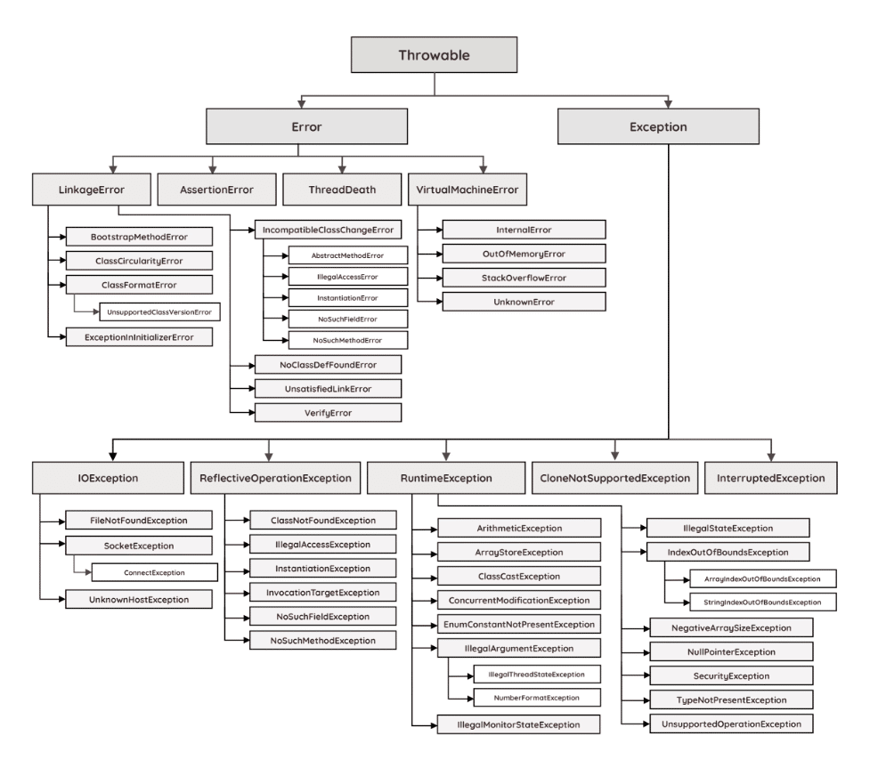

Explain the rule of handling the exception?
Resources: https://www.baeldung.com/java-exceptions

Diff between throw and throws keyword?
Resources: https://www.geeksforgeeks.org/java/throw-throws-java/

Tell me the output of below program?
Code:
public class Main {
public static void main(String[] args) {
System.out.println(handle(9));
}
private static int handle(int x) {
try {
int y = x / 0;
return 1;
} catch (Throwable t) {
return 3;
} finally {
return 5;
}
return 0;
}
}

Answer:
  - Code will not compile first, because last return statement in un-reachable as we are returning the multiple return statements before only. In try block, in catch block and also in finally block
  - If you comment out the last return statement the output will be the 5 only even it will throw the exception or not because you are returning from the finally block
  - If comment the finally block return statement then return depends on whether it will throw the exception or not and based on that the value will be returning

Code Section

Reverse the string?
Code:
public class Main {
public static void main(String[] args) {
String name = "jack parker";
char[] ch = name.toCharArray();
int start = 0;
int end = name.length() - 1;
while (start <= end) {
char temp = ch[start];
ch[start] = ch[end];
ch[end] = temp;
start++;
end--;
}
System.out.println(String.valueOf(ch));
}
}

Calculate the occurrence of each character using the stream api from the string?
Code:
import java.util.stream.Collectors;
public class Main {
public static void main(String[] args) {
String name = "jack parker";
name.chars().mapToObj(ch -> (char) ch)
.collect(Collectors.groupingBy(c -> c, Collectors.counting()))
.forEach((k, v) -> System.out.println("[" + k + ": " + v + "]"));
}
}

